RESEARCH TASK 1B

Machine Learning in Healthcare
Machine Learning can be useful in healthcare because it can learn patterns from patient data and use those patterns to make predictions. For this research task, I looked at two different applications: predicting how long a patient may stay in a hospital using Linear Regression, and detecting possible heart rhythm problems from ECG data using KNN Classification.

1) Linear Regression – Predicting Hospital Length of Stay
When a patient is admitted to a hospital, it is not always clear how many days the patient will need to stay. This makes it harder for hospitals to plan beds, staff and other resources. An estimate of the expected length of stay can make this planning easier.
Why Linear Regression?
The answer we want is a number, such as 3 days, 7 days or 12 days. Linear Regression is used to predict continuous numerical values, so it can be used to estimate the expected number of days a patient may stay in the hospital.
The model can use information available about a patient, such as age, diagnosis, severity of the condition, type of admission and whether surgery or other major treatment is required. The model learns how these factors are related to the length of stay from previous patient data.
After learning from previous cases, the model can give an estimated length of stay for a new patient. This can help hospitals plan beds, staff and resources more efficiently. It can also give doctors and hospital teams an early idea of how much care a patient may need.
Research using a large hospital dataset has tested Linear Regression for predicting patient length of stay. In one study, a Linear Regression model was used with patient features to estimate length of stay, showing that even a relatively simple regression model can provide useful information for hospital planning.
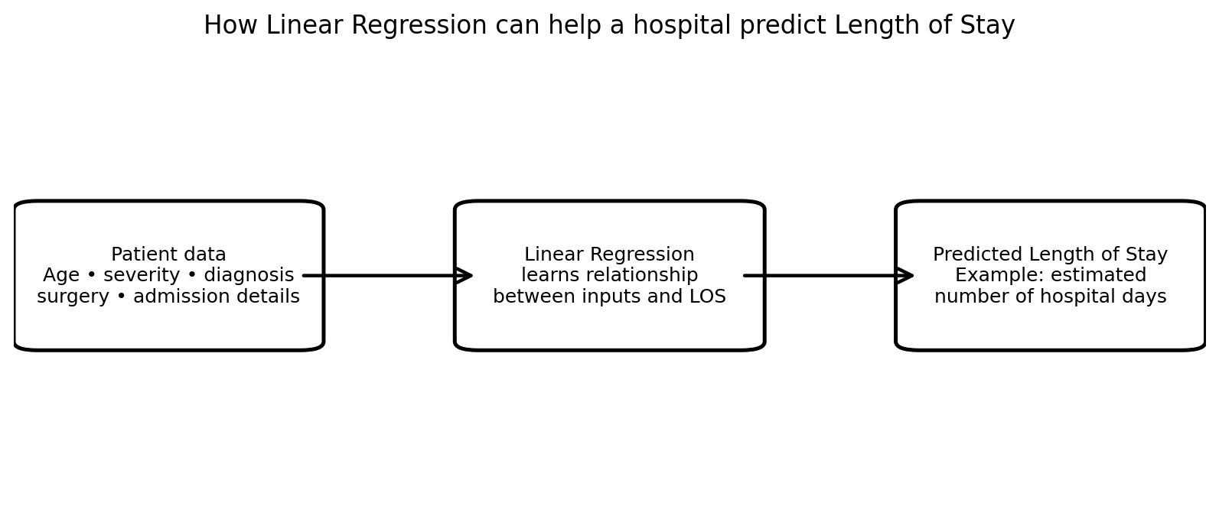
Figure 1. Simple view of how Linear Regression can be used to estimate a patient's hospital stay.

2) KNN Classification – ECG Arrhythmia(identifying abnormal heart rhythms) Detection
An ECG records the electrical activity of the heart. Different heart conditions can produce different patterns in an ECG. Looking through a large number of ECG recordings can take time, so Machine Learning can be used to help classify these patterns.
Why KNN?
Here, the output is a class, such as a normal heartbeat or a particular type of abnormal rhythm. This makes it a classification problem. KNN can compare a new ECG example with similar examples that are already labelled.
First, useful features are taken from the ECG signal. KNN then finds the K examples in the training data that are most similar to the new example. If most of those nearby examples belong to the same class, KNN gives the new example that class.
KNN works by measuring distance between data points. If one feature has much larger numbers than another feature, it can have too much influence on the distance. Scaling the features puts them on a more similar range, so the distance calculation is fairer.
KNN can help classify ECG patterns quickly and can be used as a support tool for screening. It may help healthcare professionals identify recordings that need closer attention, especially when many ECGs have to be checked.

Real example:
Researchers have tested KNN and other Machine Learning methods for classifying ECG signals and detecting different types of heart rhythm abnormalities. These studies show that ECG measurements can be converted into useful features and classified using Machine Learning.
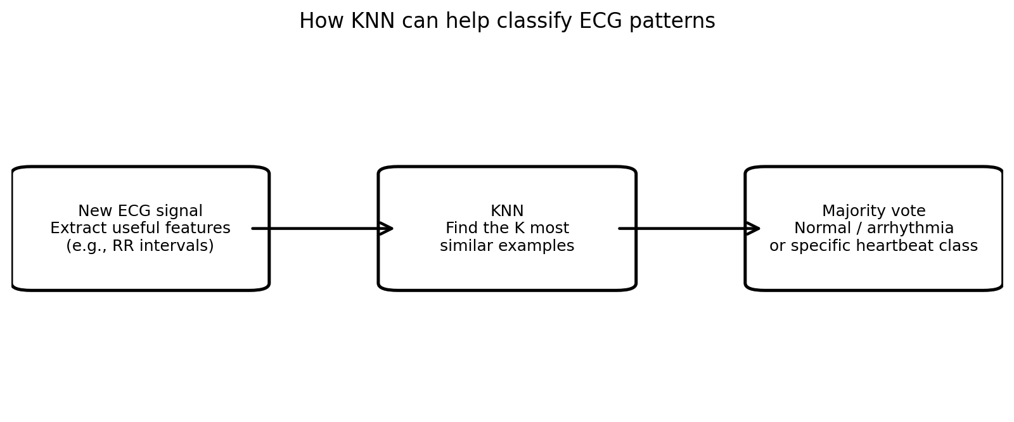
Figure 2. Simple view of how KNN can compare a new ECG pattern with similar labelled examples.
3) Quick Comparison
Model | Problem | Output | How it helps
Linear Regression | Predict hospital length of stay | Number of days | Helps hospitals plan beds, staff and resources.
KNN Classification | Classify ECG / heart rhythm patterns | A class or category | Helps screen ECG patterns by comparing them with similar examples.

4) Conclusion
Both examples show that the type of output helps us decide which Machine Learning method to use. Hospital length of stay is a numerical value, so Linear Regression can be used to predict it. ECG rhythm detection gives a category, so KNN Classification can be used to classify it.
These applications show how Machine Learning can support healthcare by finding patterns in patient data and giving useful predictions. However, the predictions are not a replacement for doctors or proper medical testing. They should be used as supporting information.
- Linear Regression → predicts a numerical value.
- KNN Classification → predicts a category.
- KNN looks at the K most similar examples before deciding the class.
- Scaling is important in KNN because KNN uses distance.
- Healthcare ML predictions should support medical decisions, not replace doctors.

Ram

